## **Design Document: S.M.A.R.T.**

**S.M.A.R.T.** — Secure ‘doc’ Management And Retrieval Technology

## **Authors**

Gurpreet K Hundal · [gurpreet@sklose.com](mailto:gurpreet@sklose.com) | Tiffany Valdecantos · [tiv001@g.harvard.edu](mailto:tiv001@g.harvard.edu)

Hellen Momoh · [hem299@g.harvard.edu](mailto:hem299@g.harvard.edu) | Spiro Habasch · sph083@g.harvard.edu

## **1. Background and Motivation**

Organizations increasingly rely on internal digital repositories—notes, policies, records—but conventional keyword-based search fails to deliver contextual understanding. SMART addresses this gap by providing an intelligent, secure, and attribution-aware retrieval system powered by LLMs and hybrid search while prioritizing data privacy and access control.

## **2. Scope and Objectives**

SMART will deliver:

* **Secure Document Storage**: Centralized, permissioned content repository (class notes, quizzes).
* **Semantic Search & Ranking**: Vector embeddings via LLM with vector and BM25 hybrid search.
* **Guardrails**: LLM powdered guardrails to avoid jailbreaking and inappropriate content.
* **LLM-Powered Summarization**: Relevant results reranked and structured via LLMs, supporting multilingual text.
* **Frontend UI**: Chatbot interface, authenticated via Google OAuth.
* **Security + Audit Trail**: Logs at every access and retrieval point.

## **3. TechStack**

| **No.** | **COMPONENT** | **TECHNOLOGY** | **PURPOSE** |
| --- | --- | --- | --- |
| 1 | Frontend | React.js, Next.js, Tailwind CSS | Provides a responsive, modular user interface. All rendering is client-side to reduce backend exposure. No sensitive logic is handled on the frontend. |
| 2 | Authentication | Google OAuth2 | Enterprise-grade identity verification. Ensures secure token-based access control with minimal attack surface. Delegates auth to trusted third party (Google), no passwords stored locally. |
| 3 | API Server | FastAPI | High-performance async Python backend. Chosen for its compatibility with local models, secure routing, and full control over all I/O. Avoids opaque cloud platforms or closed-source runtimes. |
| 4 | Database | PostgreSQL + pgvector + pgroonga | Enables hybrid semantic and keyword search without relying on external vector DBs (e.g., Pinecone, ChromaDB). Local storage with full auditability and encryption support. |
| 5 | Object Storage | Google Cloud Storage (GCS) | Used only for secure document storage. Access is abstracted via signed links, preventing direct user access. Ensures scalability while maintaining fine-grained control. |
| 6 | Embedding Models | all-MiniLM-L6-v2, all-mpnet-base-v2 (Hugging Face, local) | Lightweight and performant transformer models for encoding queries and documents into vector space. Hosted entirely locally, removing external API risks. |
| 7 | Reranker | llama3:8b via Ollama | Performs deep cross-encoder ranking. Hosted locally to ensure model weights and queries never leave the environment. Provides much better relevance over cosine alone. |
| 8 | LLM Generator | Gemma3:12b, llama3:8b via Ollama | Generates answers using rag. Chosen for open-weight licensing and strong reasoning under limited compute. Hosted securely offline. |
| 9 | Safety Filter | llama-guard3:8b via Ollama | Applies content safety and compliance filtering before LLM responses are returned. Local deployment ensures no user data leaves the system for moderation. |
| 10 | Language Detection | FastText, pattern matching | Implements high-performance language identification (176+ languages) with specialized pattern matching for short commands. Uses Facebook's FastText model for general text and regex patterns for command phrases. Completely offline detection with no API calls, optimized for speed (80x faster than previous approach). Includes translation capabilities via deep-translator. The update reflects your switch from the voting-based approach with multiple libraries to the more efficient FastText-based solution with pattern matching, while maintaining the core benefit of being fully offline. |
| 11 | Translation | deep-translator | Used for converting non-English queries to English when needed. Powered by the deep-translator library which operates offline by default. When translation fails, logs the error and returns the original text. Integrates with FastText language detection for source language identification.  This better reflects how the translation component actually functions in your implementation, highlighting its integration with the language detection system and error handling behavior. |

## **4. SMART Schema**

| No. | TABLE | DESCRIPTION |
| --- | --- | --- |
| 1 | class | Stores metadata about each class (e.g., course title, authors, term) |
| 2 | access | Manages document access control per user and class |
| 3 | document | Represents documents linked to a class |
| 4 | chunk | Contains individual document chunks + vector embeddings for retrieval |
| 5 | audit | Logs user queries, associated embeddings, retrieved chunks, and LLM outputs |
| 6 | user_tokens | Tracks OAuth token data for session validation and renewal |
| 7 | chat_history | Stores per-user chat sessions, conversation history, and timestamps |

## **5. SMART Artifacts**

Below are the artifacts of SMART deployed via docker compose.

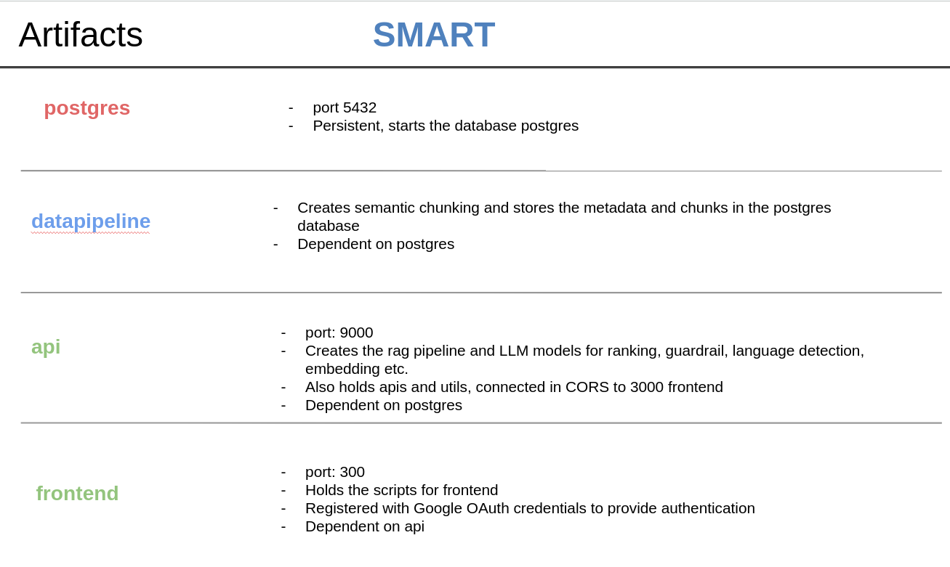

## **6. Solution Architecture**

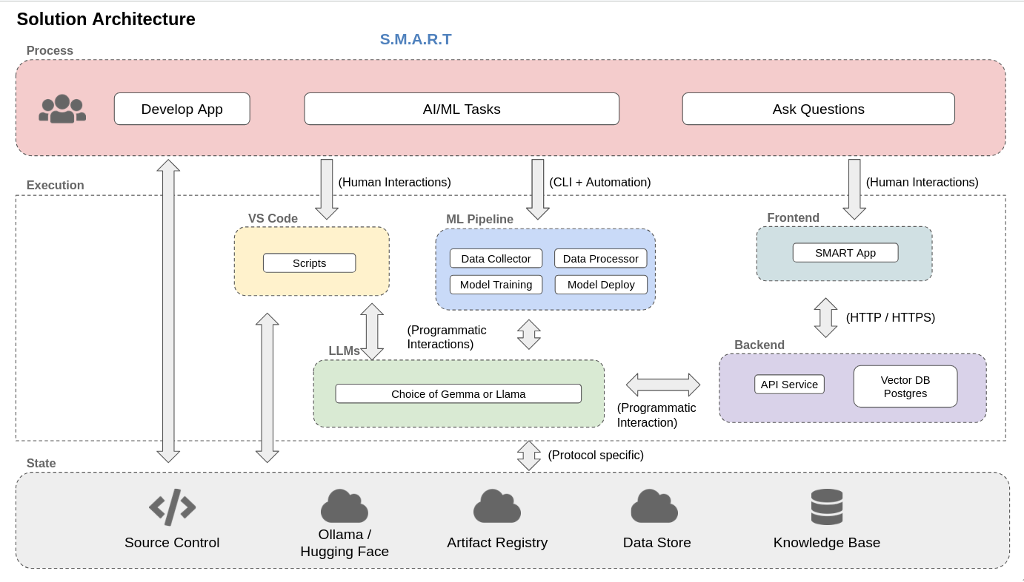

## **7. Technical Architecture**

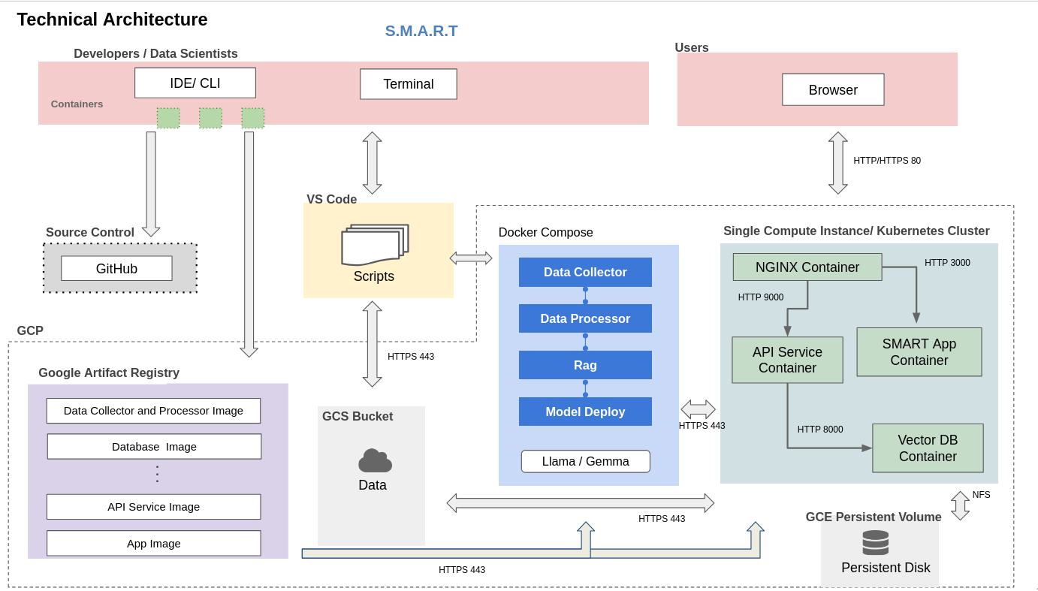

## **8. Limitations**

## 8.1. Docker

Docker operates with a central daemon (dockerd) that requires root privileges. This design can pose security risks, especially in multi-tenant environments. Containers share the kernel with the host so any kernel vulnerability could let a container break out. Additionally, pulling public images from Docker Hub poses a security risk. Docker's decision to monetize Docker Desktop for enterprise users adds on cost when other free alternatives are available as Podman and containerd. Docker Desktop relies on virtual machines to emulate a Linux environment on Windows and macOS, which can lead to performance bottlenecks and increased resource consumption.

## 8.2. Third party models

The app requires download of third party models which is again a security risk. An ideal enhancement would be to create our own distilled models that are maintained for this precise purpose thus removing dependence on third party models.